**Clicktools Survey Management**

**Creating a Survey:**

1. Log in to the clicktools by clicking on the following URL

<https://app.clicktools.com/app/home.jsp>

1. From the home page click on the **Create New Survey** button.

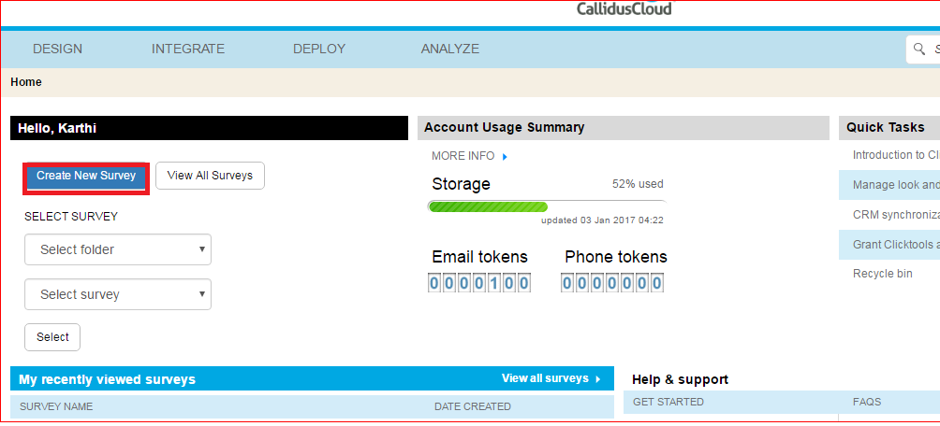

1. Enter the **Name of the survey**, **Folder, Template** and click Create.
2. Form window will open as shown below.
3. Select the type of questions from the available palette on the left hand side (Eg: Radio button or textbox or checkbox or dropdown, etc).

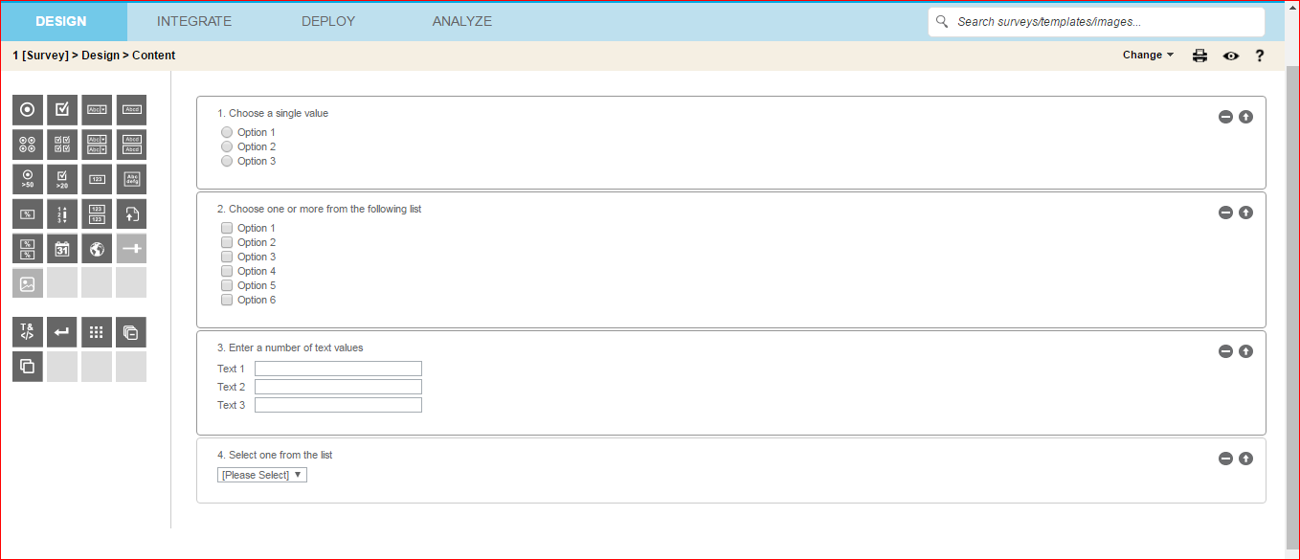

1. Now hover over the questions which you have selected to edit the properties.

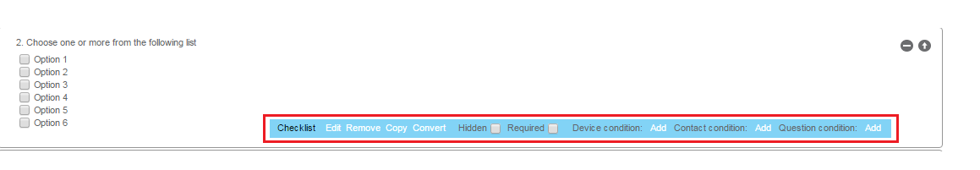

1. Edit the questions according to your requirements.

**Integrating Survey with Salesforce:**

1. Click on the **Settings** icon on the top right corner and choose **Organization 3rd party credentials.**
2. In the displaying page click in **Create new user** on right corner.
3. Select CRM as Salesforce and click Create.
4. Enter name for your org to be integrated, select sandbox checkbox, if your org is sandbox and click Create.
5. Salesforce Login page will appear. Enter the credentials and provide access.
6. You can add as many org as you want.
7. From the survey page which you have created click **Integrate 🡪 CRM settings.**

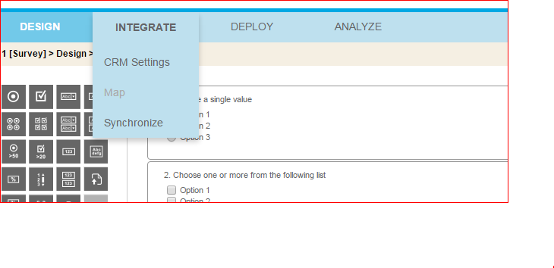

1. Select **Yes-Automatic** in Salesforce dropdown.
2. In the user dropdown select the org which you have added above and click Save.
3. Now navigate to **Integrate 🡪Map.**
4. From top Left corner select the Object from salesforce with which you have to sync your survey and click **Add New Object.**

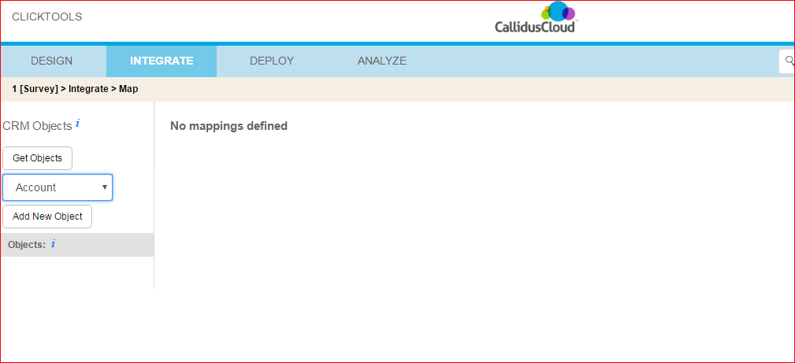

1. Once the Object is added you can create the mapping as shown below.

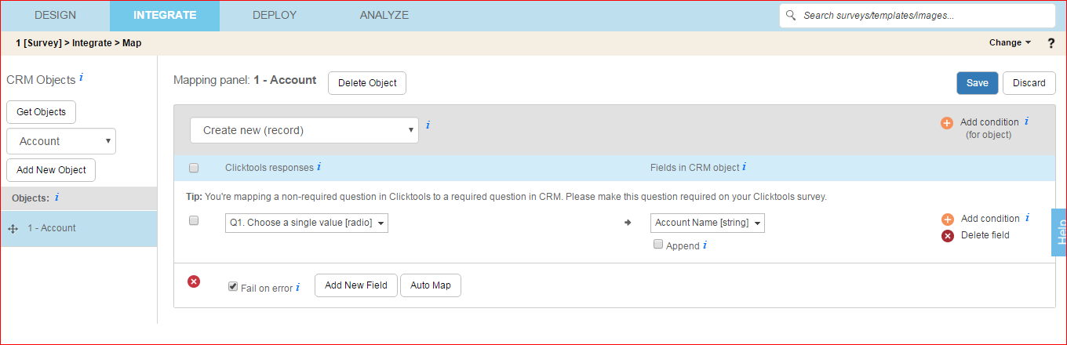

1. Once the mapping is created click Save.
2. To deploy the created Survey navigate to **Deploy 🡪 Distribute.**
3. You can directly use the link displayed or you can use the iframe code displayed in your pages.

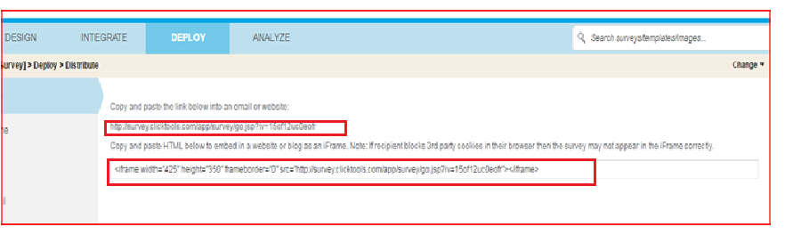

The created survey using call script template will render as below:

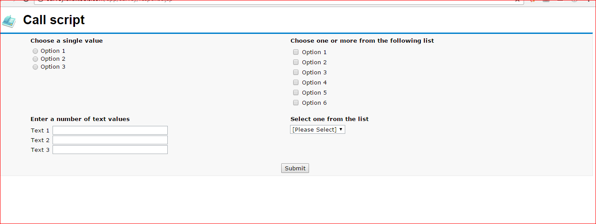

**Customizing the Survey Template using images and CSS:**

1. To customize the survey navigate to **Design 🡪 Branding .**

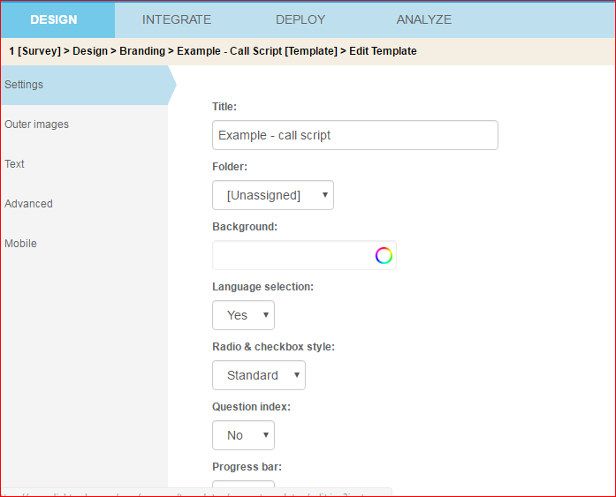

1. You can use the tabs on the left hand side for all types of customization you have to add to your survey.
2. In the advanced tab you can add HTML code to appear on top and bottom of the survey.
3. Survey after applying customizations.

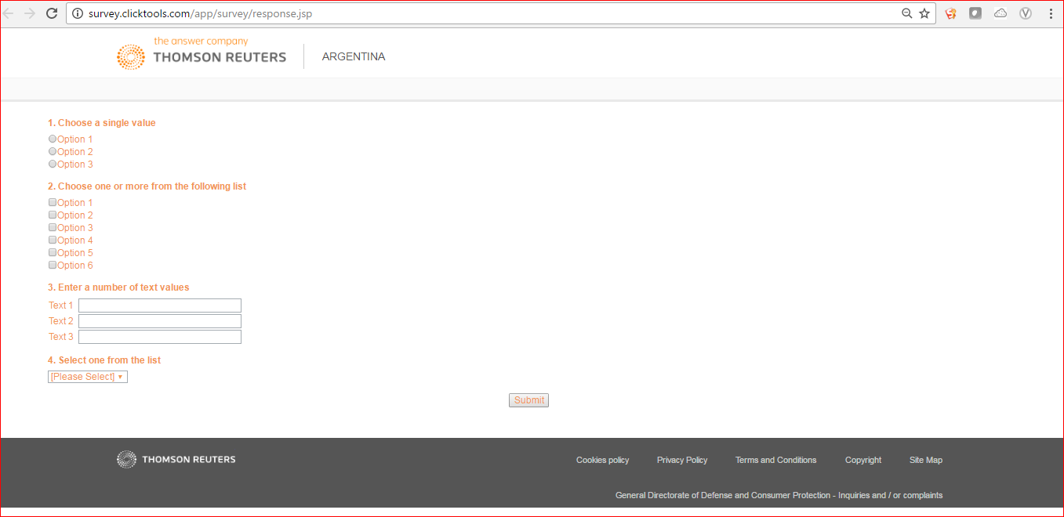

Syntax for using the value from URL in Text fields: ${question_1}